DEPARTMENT OF COMPUTER ENGINEERING
CLOUD COMPUTING & FRAMEWORKS
EXPERIMENT NO. 07
STUDY AND IMPLEMENTATION OF DATABASE AS A SERVICE (DBAAS) CLOUD SERVICE MODEL ON A SQL / NOSQL DATABASE
STUDENT DETAILS
Name: Sayyad Faizan
Class/Batch: TE CO - I 03
Roll No.: 24DCO11
Academic Year: 2024-2025
Subject: Cloud Computing & Frameworks (CCF)

1. Aim
To study the Database as a Service (DBaaS) cloud service model and understand its implementation using a managed NoSQL database (MongoDB Atlas).
2. Objectives
• Understand DBaaS cloud principles and shared responsibility models.
• Provision a managed NoSQL database deployment on MongoDB Atlas.
• Configure cluster security, IP access lists, and database credentials.
• Perform CRUD operations via MongoDB CLI (`mongosh`) and inspect results in MongoDB Atlas Data Explorer GUI.
3. Theory
3.1 What is DBaaS?
Database as a Service (DBaaS) is a cloud computing service model that provides access to database software and infrastructure without requiring manual server setup or database management.
4. Implementation Procedure & Screenshots
Step 1: MongoDB Atlas Portal Setup & Network Security
Provision cluster and configure network access in cloud console:
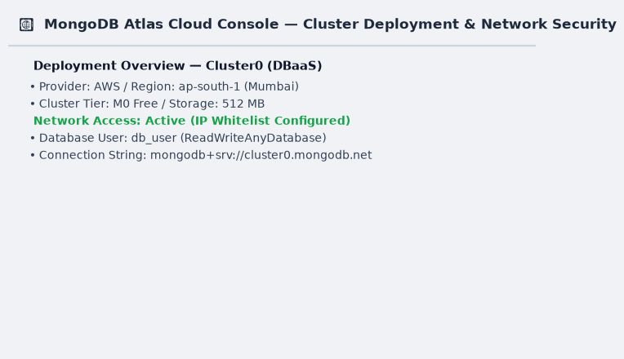
Step 2: Connect via Mongosh CLI
Connect to database using connection string:
Command: mongosh "mongodb+srv://cluster0.mongodb.net/dbaas_lab" --username db_user
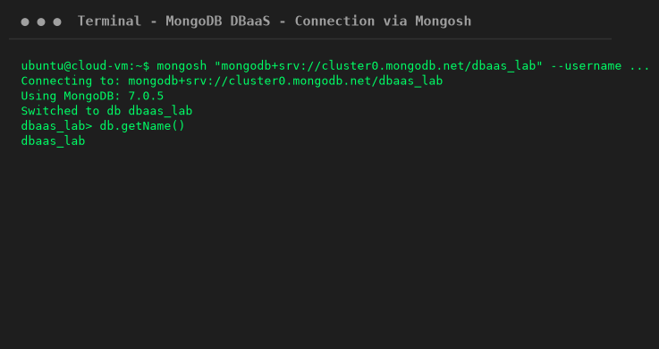
Step 3: Insert Documents (Create Operation)
Insert sample documents into students collection:
Command: db.students.insertMany([...])
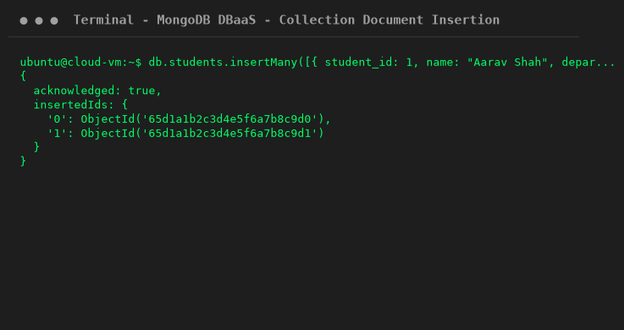
Step 4: Execute Query & Update (Read & Update Operations)
Query and update collection records:
Command: db.students.find() && db.students.updateOne(...)
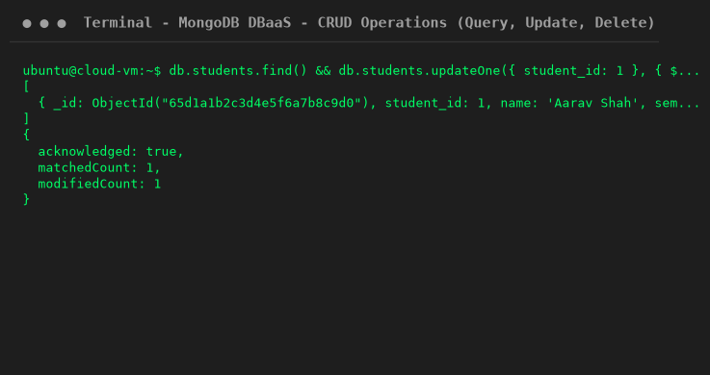
Step 5: Verify in MongoDB Atlas Data Explorer GUI
Inspect updated documents inside Atlas web console:
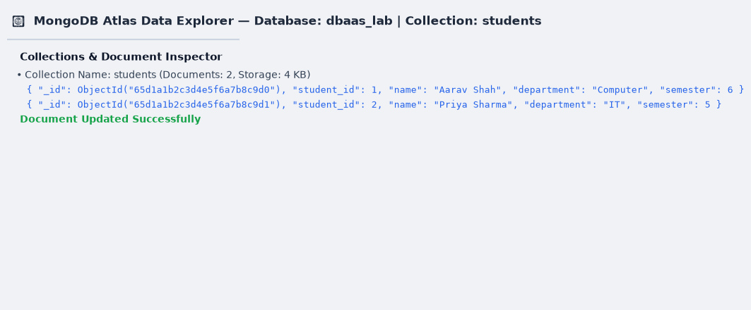
5. Viva Questions & Conclusion
Q1: What is DBaaS?
Ans: A cloud model delivering managed database infrastructure over the internet.
Q2: What is MongoDB Atlas?
Ans: A fully managed cloud NoSQL database service.
Q3: What does CRUD stand for?
Ans: Create, Read, Update, and Delete.
6. Conclusion
In this experiment, Database as a Service (DBaaS) concepts were studied and implemented using MongoDB Atlas cloud cluster, CLI (`mongosh`), and Data Explorer GUI.

